Lab 3 Part 1: Implementing Circuits on a Breadboard
CSCE 2114 Digital Design laboratory

During this lab you will construct a multiple circuits and document their operation. The ICs available are the 7400, 7402, 7404, 7408, 7410, 7411, 7427, and the 7432 (though the problem statement may restrict what chips you may use). You will construct each design using the PB-505 trainer. The lab problem statements as well as a diagram of each IC are shown below.

Lab Problems
- Read the tips section on the next page.
- Implement F(A,B,C) = Σm(0,3,7) in canonical sum-of-products form using only 3 IC chips.

- Implement a NAND gate only version of F(A,B,C) using only 3 IC chips (7410).

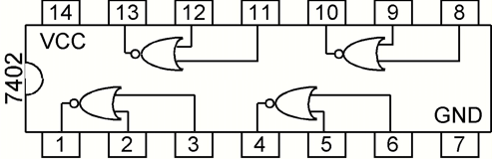
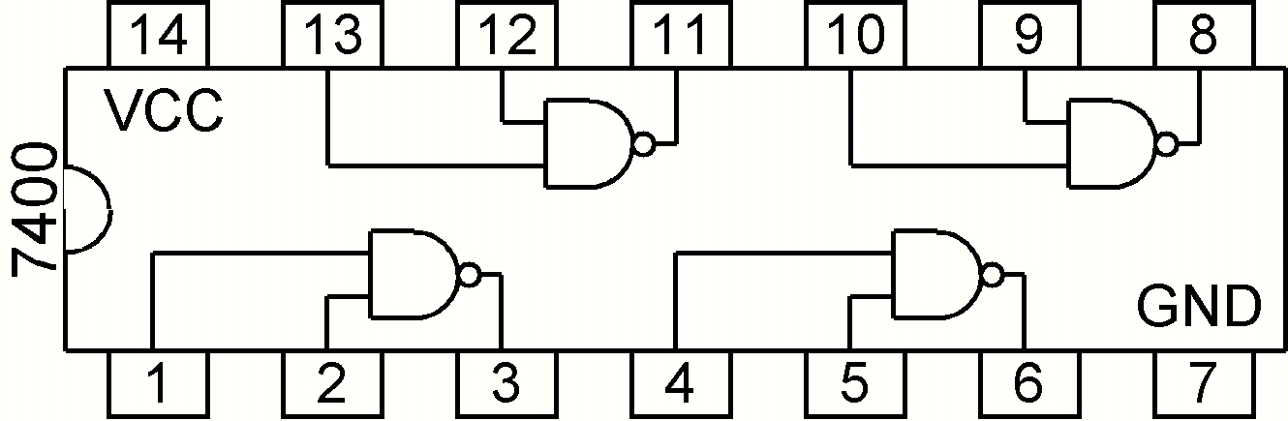

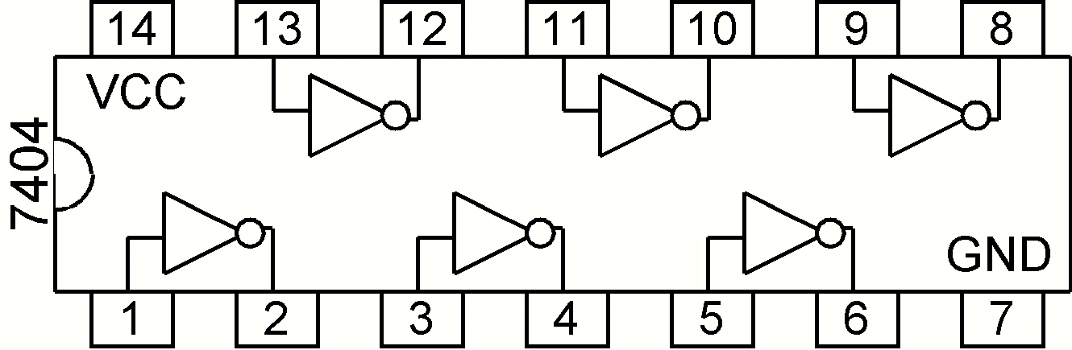
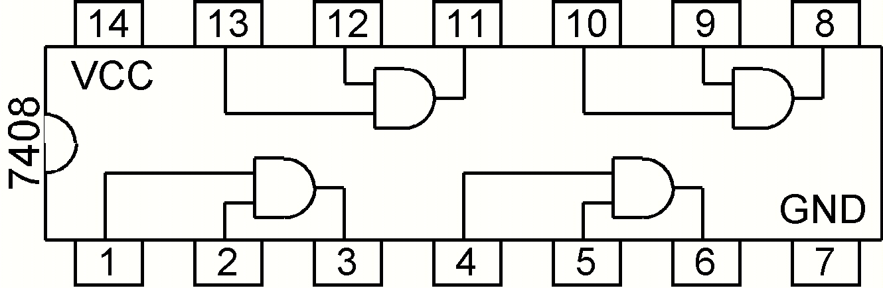

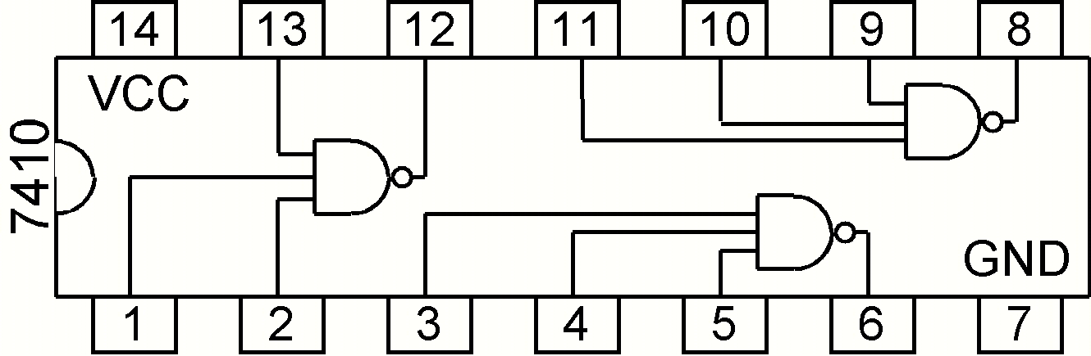
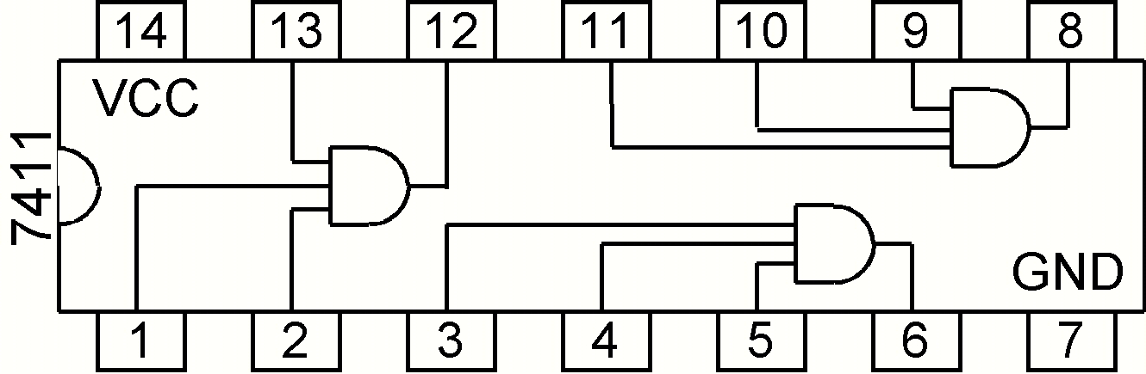

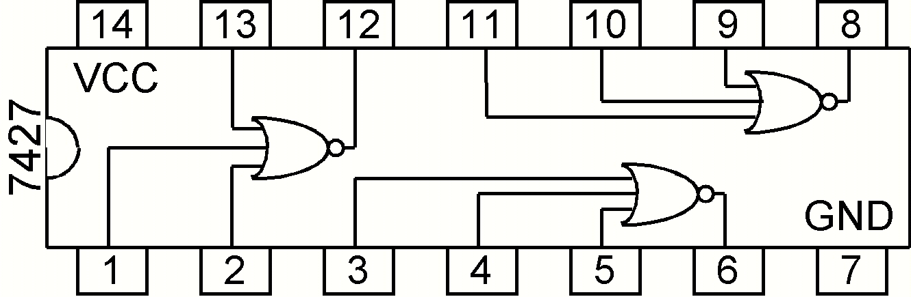
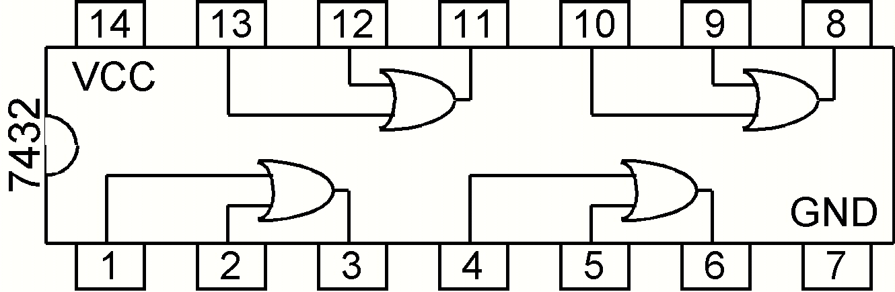

Tips
- You will notice that there is no 3-input OR gate in the lab. You will have to use some other gates to construct the equivalent of one.
- Remember each IC chip needs to be connected to power and ground.
- Keep the board powered off when changing connections on the breadboard; only turn it on when you are ready to test your circuit.
- Make sure no pins are broken on the IC chips you are using. If they are a little bent, it is okay as long as they fit in the breadboard. Be careful when putting the chip in the breadboard so that you don’t break or bend any of the pins.
- If your circuit doesn’t work, check these common problems before asking for help:
  - Is power and ground connected to each IC chip?
  - Are any IC chips backwards? Look for the notch on one end.
  - Trace input and output connections to make sure your breadboard matches the schematic.
- You may need to refer back to the Lab 1 document if you cannot remember something from that lab.

Lab Report
There will be no lab report due next week. The lab report will be due one week after we complete part 2 of this lab; however, you should include these things in your final lab report.
- Truth table for F
- Boolean equations for each part
- Schematics for each part
- What were 2 things you learned from this lab?
- What could be improved about this lab?

